AP Psych Review Video 6.1-6.3

Physical, Social & Cognitive Development in Childhood

Directions: Visit the AP Psych page on YouTube and watch Video 6.1-6.3. This lesson reviews content from Unit 6 and Myers Psychology for AP* Book Unit 9. Complete the guided viewing notes and exit ticket to receive credit for today’s assignment.

FRQ Review Last Lesson:
Fluid Intelligence | Flynn Effect | Triarchic Theory | Operational Def
Definition: | Definition: | Definition | Definition
Application | Application | Application | Application
Synonym | Synonym | Synonym | Synonym
Crystallized Intelligence | Savant Syndrome | Criterion Validity | Reliability
Definition: | Definition: | Definition | Definition
Application | Application | Application | Application
Synonym | Synonym | Synonym | Synonym
How Did You Do?

Conception & Gestation (Prenatal Dvpt)
Conception | Germinal Stage | Embryonic Stage | Fetal Stage
Factors for Successful Prenatal Dvpt: | 1. 3. 5.  2. 4.
Nature v Nurture in Physical Dvpt
NOT TABULA RASA! | Sensory Abilities | Motor Development
Maturationism-

Attachment & Socialization
Temperament | Def:
 | Types:
Strange Situation &  Attachment Styles | Def:
Visual Cliff
Still Face Exper:
Harry Harlow | Methods: |  | Findings:

Other Major Researchers in Developmental Psych
Konrad Lorenz |  | Imprinting
Diana Baumrind | 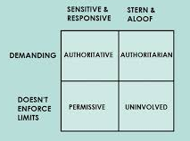 | Parenting Styles

Nature v Nurture in Social Dvpt
IT IS NOT…  IT IS... | Reciprocal Determinism | 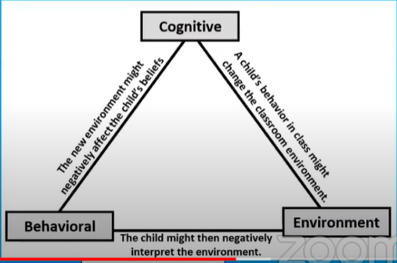
Swope, Cram Plan for AP, 2020 Cliffs Notes Publishers

Baumrind’s Parenting Styles (cont)
Parenting Style | Parent’s Behavior | Child’s Behavior
Permissive
Authoritative
Authoritarian
Uninvolved
Swope, Cram Plan for AP, 2020 Cliffs Notes Publishers

Cognitive Development in Childhood
Jean Piaget | *Don’t forget schemas, assimilation & accommodation!
Sensorimotor | Preoperational | Concrete Operations | Formal Operations
Age: | Age: | Age: | Age:
Key Ideas/Terms | Key Ideas/Terms | Key Ideas/Terms | Key Ideas/Terms

Lev Vygotsky | Scaffolding | Zone of Proximal Dvpt
Key Ideas:

AP Exam Practice (15 min timer):

Little Timmy S has had an amazing couple of years. From being born just a few short years ago, to walking and talking. So many things have happened and so many things have changed in a few short years. His mother, Mommy S, is not sure if it was her efforts that led to Timmy’s development or if he did it all by himself.

Part A: Please explain whether the following terms are most likely related to Timmy’s efforts or his mother’s.
- Proximal distal development

- Zone of proximal development

- Egocentrism

- Teratogens

Exit Ticket:
I Feel Confident/Better About: | But I Still Have Questions Surrounding:

